**Big Mountain Resort Pricing Optimization**

Big Mountain Resort (BMR) currently charges $81 for an Adult Weekend ticket. The current impression is that BMR can charge more than their competitors for their passes due to their inclusion of more amenities. There is an alternative opinion that ticket sales may be lower due to this higher price that is not offset by the increased per pass income. The task that this analysis will attempt is to justify potential changes to pricing and amenities based on competitors analysis.

Specific questions to be answered in this analysis are:

1. How can revenue be positively affected for the upcoming season by ticket price or amenity changes that are driven by usage data?
2. Should prices be increased due to quality amenities?
3. Should prices be decreased?
4. Should amenities which are underutilized or don’t add value to BMR be removed?

The initial dataset contained amenity and pricing data about 330 skiing resorts including BMR. The ticket prices distribution by state seems to suggest that while BMR has a high ticket price for Montana they are not extreme in the total population of competitors. 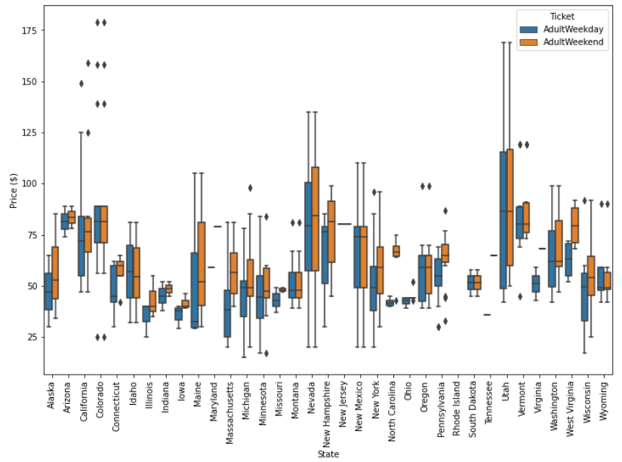

In the full analysis only 277 resorts were used due to several of the resorts having missing data. After several models were evaluated it was determined that a random forest regression model provided the best predictability for Adult Weekend ticket prices. The most impactful amenities based on this modeling were: # of Fast Quads, # of Runs, Snow Making Ac., and Vertical Drop.

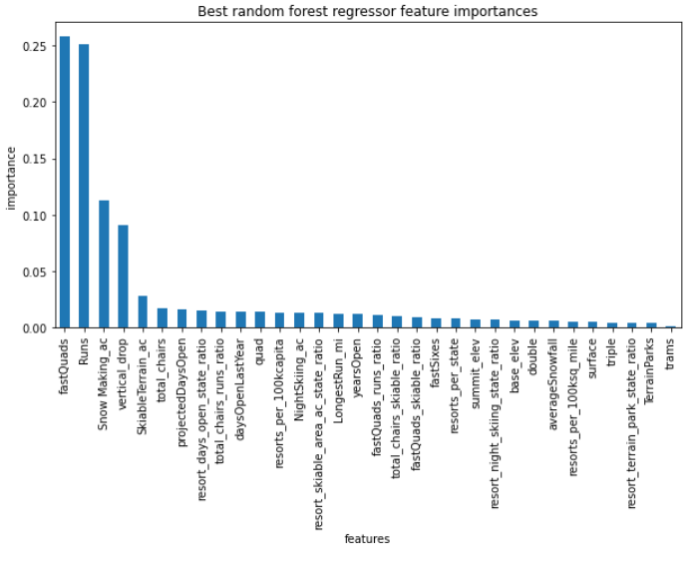

Based on the modeling Weekend Ticket price should be $95.87 based on current amenities. Based on this it appears there might be room for a ticket price increase. Something that becomes clear when plotting the important factors that drove the model is that Big Mountain Resort already has high values for all of the price driving amenities EXCEPT for Trams. Based on the evaluated scenarios only the closing of runs or the addition of vertical drop scenarios would be worth further consideration.

Current recommendations to be considered:

1- Increase the price of tickets to better reflect the high quality of the amenities at Big Mountain Resort. Based on the estimate of 350,000 visitors averaging a 5 day visit this would increase revenue by up to $26.3 million. The counter argument to this approach is that Big Mountain already has the most expensive ticket in Montana by more than $10. An increase to the modeled price of $95 would make it $25 per ticket more expensive than their geographically closest competitors.

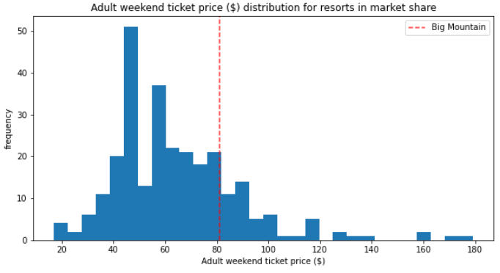

2- Close 5 or 8 runs. Additional information on the cost to keep runs open would be required to provide an estimate of financial impact for this approach. The modeling seems to indicate that there are some logical breaks in the closing of runs. Closing 3 to 5 runs reduces the price support by $0.67, and 6 to 8 reduces it by $1.26. Because there is evidence that the BMR is already a great value for the amenities that it provides there would not be a need to reduce the price based at this time due to these changes. If this approach is considered I would recommend evaluating if there are particularly expensive or less popular runs to target for closure.

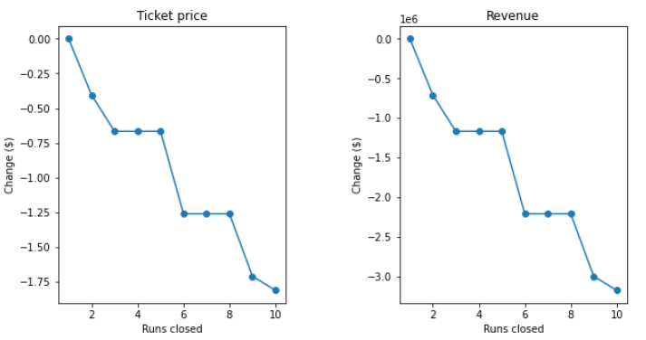

3- Increase Vertical Drop by 150 ft. This would provide an additional $1.99 in pricing support. Although the value of this added amenity would be an additional $3.5 million in revenue based on the modeling, it does not make sense to add an amenity to increase price support if there is resistance to increasing the cost of a ticket based on the current amenities. This added revenue would also need to be balanced against the cost of the additional chair lift and it's cost to operate.